Indonesia Pushes for ASEAN-New Zealand Cooperation
to Address Development Challenges in the Pacific

Jakarta, 13 July 2022. Foreign Minister Retno Marsudi urged ASEAN and New Zealand to strengthen cooperation in maintaining stability in the Indo-Pacific, including the Pacific region. Minister Retno conveyed that New Zealand is an important partner of ASEAN in the Pacific region.

The statement was made by Foreign Minister Retno during the ASEAN - New Zealand Post Ministerial Meeting on the sidelines of the 56 ASEAN Foreign Ministers' Meeting, on Thursday (13/7) in Jakarta.

In the meeting, the following issues were discussed:

First, Foreign Minister Retno welcomed the signing of the ASEAN - Australia - New Zealand Free Trade Agreement (AANZFTA) amendment.

Second, Foreign Minister Retno acknowledged New Zealand's important role in bridging ASEAN and the Pacific region.

Third, regarding stability in the Pacific, Foreign Minister Retno stated that the stability of the Pacific region is an integral part of stability in the Indo-Pacific. Therefore, ASEAN and New Zealand must strengthen cooperation to uphold strategic trust in the region and uphold international law, including the principles of sovereignty and territorial integrity.

"We hope that New Zealand will continue to support the centrality of ASEAN in shaping the regional order and promoting collaboration in the Pacific," said Foreign Minister Retno.

Fourth, regarding development issues in the Pacific, Foreign Minister Retno stated that ASEAN must assist the Pacific countries in facing various development challenges, including climate change and maritime issues.

"We must ensure concrete cooperation that is in line with the ASEAN Outlook on the Indo-Pacific (AOIP)," explained Foreign Minister Retno.

Minister Retno also expects New Zealand to play a role in bridging ASEAN cooperation in the Pacific, including on the plan for cooperation between the secretariats of ASEAN and the Pacific Island Forum (PIF).

During the meeting, ASEAN countries emphasized the strengthening of cooperation in the fields of economy, maritime affairs, and marine issues, fulfilling commitments to the Paris Agreement, counter-terrorism cooperation, and combating human trafficking. They also expect New Zealand to support ASEAN's common position on the South China Sea.

The ASEAN-New Zealand Joint Statement on Cooperation on the ASEAN Outlook on the Indo-Pacific was adopted by the ASEAN-New Zealand Foreign Ministers in the meeting, highlighting the importance of inclusive collaboration in the Indo-Pacific region.

***

For further information, please contact the following:

Director for Information and Media of the Ministry of Foreign Affairs - Hartyo Harkomoyo (+62811831899)

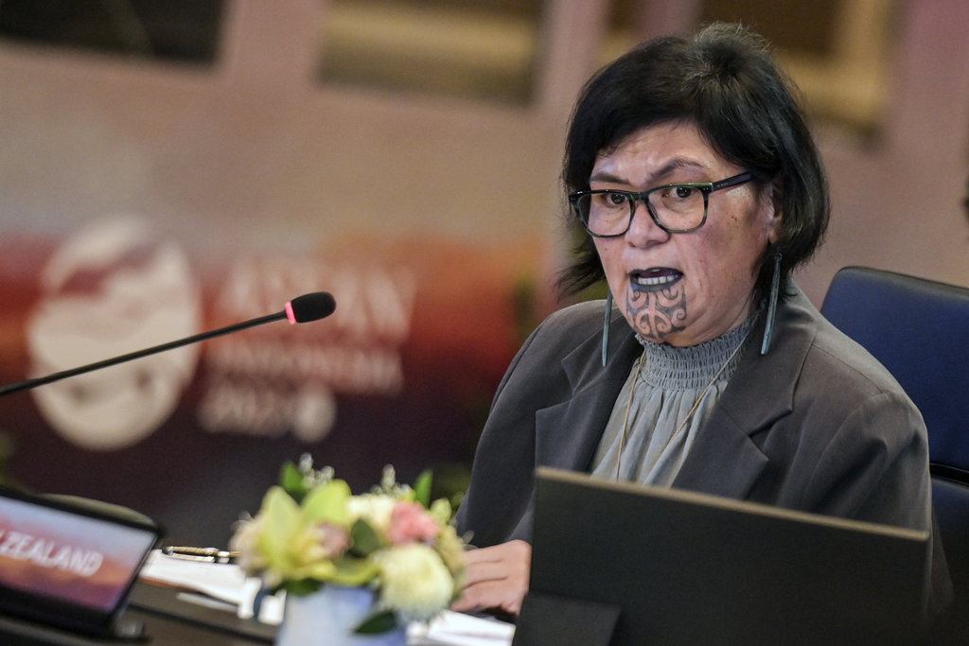

Indonesia urged ASEAN and New Zealand to strengthen cooperation in maintaining stability in the Indo-Pacific during the ASEAN - New Zealand Post Ministerial Meeting on the sidelines of the 56 ASEAN Foreign Ministers' Meeting in Jakarta (13/7) (Photo: Ministry of Foreign Affairs of Indonesia).

